CSA1012-SOFTWARE ENGINEERING
TELEMEDICINE PLATFORM FOR VIRTUAL DOCTOR CONSULTATIONS
Course: Software Engineering
Assignment: – Architecture Design Assignment (CO2 AT-2)
Submitted by: Dhushyanth Kumar V
Register No.: 192511335
Guided by: Dr.K.Anita Davamani

Problem Statement Overview
Healthcare providers need a way to deliver medical consultations remotely, without requiring patients to travel to a clinic. The assigned problem is to design and develop a secure, scalable telemedicine platform that connects patients and doctors for virtual consultations.
The platform must support patient registration, doctor scheduling, appointment booking, real-time video consultations, electronic medical records (EHR), digital prescriptions, secure role-based authentication, integrated payments, and notifications — while meeting healthcare-grade security, availability, and compliance requirements (e.g., HIPAA/GDPR-style data protection).

1. Analyze System Requirements

1.1 System Objectives
- Enable patients to register, search for doctors, and book virtual appointments.
- Enable doctors to manage availability, conduct video consultations, and issue digital prescriptions.
- Maintain a secure, centralized electronic health record (EHR) per patient.
- Support secure payments for consultations and automated notifications (appointment reminders, prescription alerts).
- Provide administrators with tools to manage doctors, patients, and platform operations.
- Guarantee data privacy, regulatory compliance, and high system availability.

1.2 Functional Requirements
- Patient registration, login, and profile management.
- Doctor registration, credential verification, and schedule/availability management.
- Appointment search, booking, rescheduling, and cancellation.
- Real-time audio/video consultation between patient and doctor.
- Creation, storage, and retrieval of electronic medical records (EHR).
- Digital prescription generation, download, and pharmacy hand-off.
- Online payment processing for consultation fees.
- Automated SMS/email notifications for bookings, reminders, and prescriptions.
- Role-based dashboards for Patients, Doctors, and Administrators.

1.3 Non-Functional Requirements
Attribute | Requirement
Scalability | Must support a growing number of concurrent patients, doctors, and video sessions without performance degradation.
Security | End-to-end encryption for video calls, encrypted storage of EHR, secure authentication (OAuth2/JWT), RBAC.
Availability | 24x7 uptime (target 99.9%) since consultations may be needed at any time, including emergencies.
Performance | Low-latency video streaming; API responses within acceptable thresholds (e.g., sub-second for booking operations).
Reliability | No data loss for medical records/prescriptions; consistent appointment state across services.
Maintainability | Independently deployable, modular components enabling frequent, low-risk updates.
Compliance | Adherence to healthcare data protection standards (HIPAA/GDPR-equivalent), audit logging.
Usability | Simple, intuitive UI for patients, doctors, and administrators across web and mobile.

1.4 Key Quality Attributes Driving the Architecture
Given the domain (healthcare) and the need for real-time interaction, five quality attributes most strongly shape the architecture: (1) scalability — to handle variable consultation load; (2) security — to protect highly sensitive patient data; (3) availability — since care cannot be delayed; (4) performance — for smooth video consultations; and (5) maintainability — to allow features (e.g., lab integration) to be added over time without destabilizing the whole system.

2. Select a Suitable Software Architecture

2.1 Selected Architectural Style: Microservices Architecture (with Event-Driven communication and an API Gateway)
A Microservices Architecture is selected as the primary architectural style, combined with an API Gateway for unified client access and an event-driven message broker for asynchronous inter-service communication.

2.2 Justification
- Independent scalability: Video consultation and appointment booking experience different, unpredictable load patterns (e.g., peak booking hours vs. peak consultation hours). Microservices allow each capability to be scaled independently, unlike a monolith where the entire application must be scaled together.
- Domain alignment: The problem naturally decomposes into bounded contexts — patient management, doctor scheduling, appointments, video consultation, EHR, prescriptions, payments, and notifications — which map cleanly onto separate services with clear ownership.
- Security isolation: Sensitive EHR and prescription data can be isolated into their own services and databases with stricter access controls, rather than being exposed through a single shared codebase and database as in a monolith.
- Fault isolation and availability: If the notification or payment service fails, patients can still book appointments and attend consultations — the failure is contained rather than bringing down the whole platform.
- Independent, frequent deployment: Features such as digital prescriptions or new payment methods can be updated and deployed without redeploying the entire system, improving maintainability.
- Technology fit: Video consultation benefits from a specialized WebRTC-based media pipeline, which is easier to isolate and optimize as its own service rather than bundling it into a general-purpose monolith.

Alternative styles considered: A layered monolithic architecture was considered for its simplicity and lower operational overhead, and a Serverless architecture was considered for cost efficiency on intermittent workloads. However, monolithic architecture limits independent scaling of the video-consultation module and increases blast radius for failures, while pure serverless is less suited to stateful, long-lived video sessions. A hybrid — microservices for core domain services with serverless functions for lightweight tasks (e.g., notification dispatch) — is a reasonable extension, but microservices remains the primary style for this design.

3. Software Architecture Diagram
The diagram below shows the layered microservices architecture: client applications, an API Gateway and security layer, the core microservices, an asynchronous event bus, the data layer, and external third-party systems.
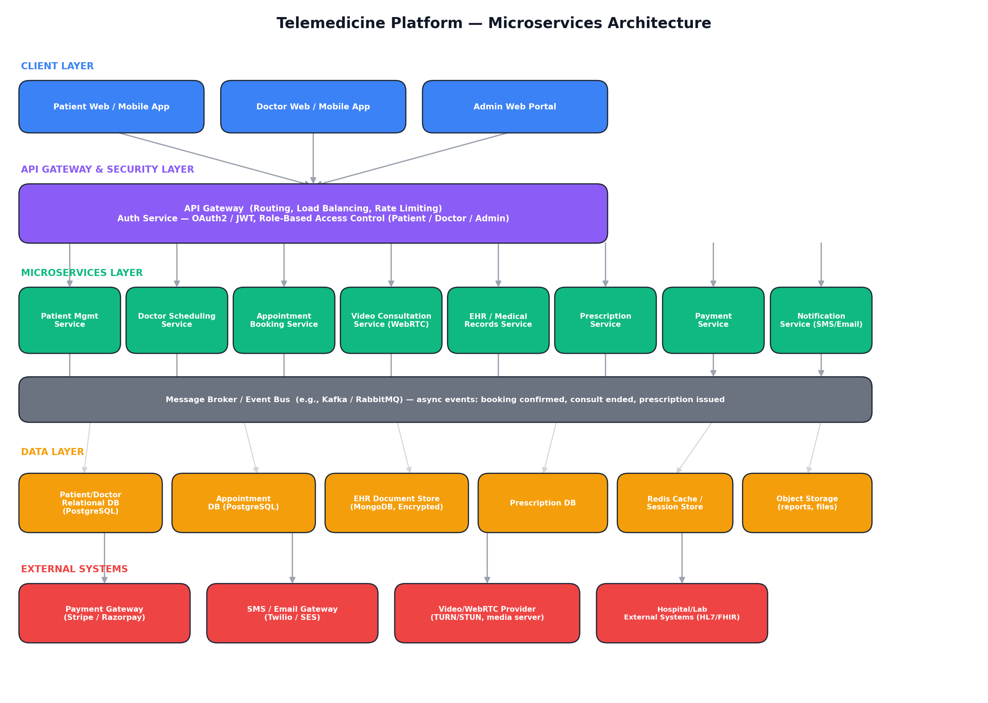
Notation: rectangles represent components/services; arrows represent synchronous request/response calls (client → gateway → services → databases) and, via the event bus, asynchronous publish/subscribe events between services.

4. Components and Their Interactions

4.1 Component Responsibilities
Component | Responsibility
Client Apps (Patient/Doctor/Admin) | Role-specific UIs for registration, booking, consultations, records, and administration.
API Gateway | Single entry point; routes requests, load-balances, applies rate limiting, and enforces coarse-grained security.
Auth Service | Authenticates users and issues JWT/OAuth2 tokens; enforces role-based access control (RBAC).
Patient Mgmt Service | Manages patient profiles, medical history intake, and preferences.
Doctor Scheduling Service | Manages doctor profiles, specializations, and availability calendars.
Appointment Booking Service | Handles search, booking, rescheduling, and cancellation of appointments.
Video Consultation Service | Establishes and manages real-time WebRTC audio/video sessions between patient and doctor.
EHR / Medical Records Service | Stores and retrieves encrypted electronic health records and consultation notes.
Prescription Service | Generates, stores, and shares digital prescriptions after a consultation.
Payment Service | Processes consultation fees securely via a third-party payment gateway.
Notification Service | Sends booking confirmations, reminders, and prescription alerts via SMS/email.
Message Broker / Event Bus | Decouples services via asynchronous events (e.g., 'appointment booked', 'consultation ended').

4.2 Communication and Workflow
- All client requests pass through the API Gateway, which authenticates the caller via the Auth Service and routes the request to the appropriate microservice — this is synchronous, request/response communication (typically REST/HTTPS or gRPC).
- A patient books an appointment: Appointment Booking Service checks Doctor Scheduling Service for availability, reserves the slot, and publishes an 'AppointmentBooked' event to the message broker.
- The Notification Service subscribes to 'AppointmentBooked' events and sends a confirmation to both patient and doctor — this is asynchronous, event-driven communication, which keeps booking fast and decouples notification delivery from the booking transaction.
- At consultation time, the Video Consultation Service establishes a peer-to-peer (or relayed) WebRTC session between patient and doctor apps, using a TURN/STUN provider for NAT traversal.
- After the consultation, the doctor's app calls the EHR Service to record notes and the Prescription Service to issue a digital prescription; a 'ConsultationCompleted' event triggers the Notification Service to alert the patient.
- Payment can occur at booking or post-consultation; the Payment Service integrates with an external payment gateway and publishes a 'PaymentConfirmed' event once settled.
- Each service owns its own database (database-per-service pattern), preventing tight coupling at the data layer and allowing each store to be optimized for its data shape (e.g., document store for EHR, relational store for appointments).

5. Discuss Quality Attributes

5.1 Scalability
Each microservice can be scaled horizontally and independently based on demand — for example, the Video Consultation Service can be scaled up during peak consultation hours while the Prescription Service remains at baseline capacity. The API Gateway performs load balancing across service instances, and the event bus buffers bursts of asynchronous work (e.g., a wave of notifications) without blocking core transactions.

5.2 Security
All external traffic is encrypted (TLS) and authenticated at the API Gateway using OAuth2/JWT, with role-based access control restricting patients, doctors, and admins to their permitted operations. Video sessions use encrypted WebRTC media streams. EHR and prescription data are encrypted at rest in isolated databases with restricted access, and audit logging tracks access to sensitive records to support compliance.

5.3 Performance
The API Gateway and caching layer (Redis) reduce latency for frequently accessed data such as doctor availability. The Video Consultation Service is isolated so that its real-time performance requirements are not affected by load on unrelated services (e.g., report generation), and a dedicated media/TURN infrastructure keeps video latency low.

5.4 Reliability
The database-per-service pattern and event-driven design prevent a failure in one service from directly corrupting another service's data. Asynchronous events (e.g., notifications) are queued and retried rather than lost if a downstream service is temporarily unavailable, improving overall data and delivery reliability.

5.5 Maintainability
Because each service is independently deployable with a well-defined API, teams can update, test, and release individual services (e.g., adding lab-integration to EHR) without redeploying the entire platform, reducing regression risk and simplifying long-term maintenance.

5.6 Availability
Service isolation means the platform degrades gracefully: if the Payment or Notification service experiences an outage, patients can still complete video consultations. Combined with redundant service instances behind the API Gateway and health-check-based failover, the design supports the high (24x7) availability required for healthcare access.

6. Justify Architectural Decisions

6.1 Rationale
The core rationale for choosing microservices with an API Gateway and event-driven messaging is that the telemedicine domain has clearly separable responsibilities with different scaling, security, and reliability needs (particularly the real-time video component and the highly sensitive EHR component). A single monolithic architecture would force all components to share the same scaling profile, deployment cycle, and failure domain, which is a poor fit for a system where video-consultation load, appointment-booking load, and administrative load vary independently.

6.2 Trade-offs Considered
- Operational complexity vs. flexibility: Microservices introduce more moving parts (service discovery, distributed monitoring, inter-service network calls) compared to a monolith, but this is accepted in exchange for independent scalability and fault isolation, which are critical in a healthcare context.
- Eventual consistency vs. strict consistency: Using an event bus for cross-service updates (e.g., notifications) means some operations are eventually consistent rather than instantly consistent; this is acceptable for notifications but not for core medical/appointment data, which is why those flows use direct synchronous calls with transactional guarantees within each service.
- Cost vs. simplicity: Running many services increases infrastructure and DevOps overhead compared to a simpler layered/monolithic build; this cost is justified by the platform's expected growth and the criticality of isolating patient data.

6.3 Future Enhancements and Long-Term Maintainability
- New capabilities (e.g., AI-based symptom triage, lab-report integration via HL7/FHIR, wearable-device data ingestion) can be added as new microservices without altering existing services.
- The API Gateway simplifies integration with future external systems (insurance providers, pharmacy networks, hospital EMR systems) by exposing controlled, versioned APIs.
- Containerization (Docker) and orchestration (Kubernetes) allow the platform to auto-scale services independently as user volume grows, and to roll out updates with zero downtime.
- The event-driven backbone makes it straightforward to add new subscribers (e.g., an analytics service) without modifying the services that publish the events, supporting long-term extensibility.

7. Supporting Tools Used for Design and Documentation
The following collaborative software engineering tools were used (or would be used in a real team setting) to plan, design, and document this architecture:
- Jira: to break down the objectives into an epic/story backlog (e.g., 'Patient Registration', 'Video Consultation', 'Digital Prescriptions') and track sprint progress for each microservice team.
- Figma: to design low- and high-fidelity UI/UX mockups for the Patient App, Doctor App, and Admin Portal, and to validate the user journey for booking and attending a consultation before development.
- Confluence: to document requirements, architectural decisions (ADRs), API contracts between services, and this architecture design report for team-wide visibility.
- draw.io / Lucidchart (diagramming): to author and iterate on the architecture and sequence diagrams, such as the microservices diagram in Section 3.
- Postman: to design, test, and document the REST APIs exposed by each microservice through the API Gateway.
Together, these tools support the traceability from requirements (Jira/Confluence) through UI design (Figma) to the technical architecture and API contracts (draw.io/Postman) documented in this report.

